Setting up an AWS Lambda function to trigger whenever an object is uploaded to an S3 bucket and update a DynamoDB table
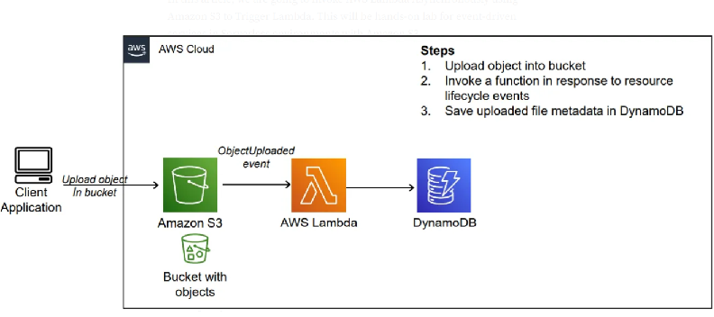
step-by-step procedure for setting up an AWS Lambda function to trigger whenever an object is uploaded to an S3 bucket and update a DynamoDB table:
1. Create an AWS Account: If you haven't already, sign up for an AWS account at https://aws.amazon.com/.
2. Access AWS Management Console: Log in to the AWS Management Console using your AWS account credentials.
3. Open AWS Lambda Console: Navigate to the Lambda service by either searching for "Lambda" in the AWS Management Console or
4. Create a New Lambda Function:
- Click on the "Create function" button.
- Choose "Author from scratch".
- Enter a name for your function (e.g., "S3ToDynamoDB").
- Choose Python as the runtime.
- Under "Permissions", create a new role with basic Lambda permissions or choose an existing role that has permissions to access S3 and DynamoDB.
- Click on the "Create function" button.
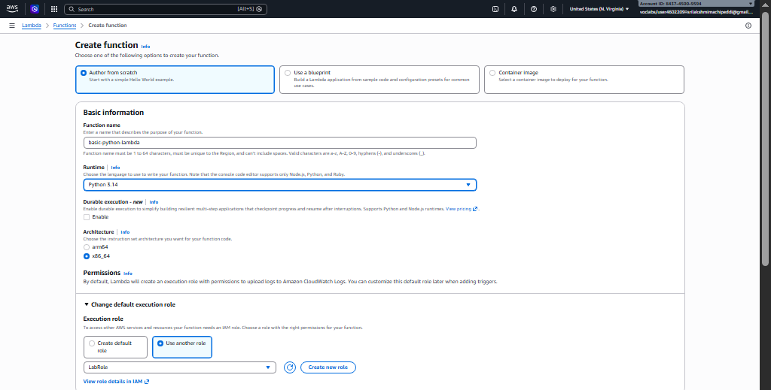
5. Upload Code:
- Write the Python code for your Lambda function. This code will be triggered whenever an object is uploaded to the specified S3 bucket.
- Here's an example code snippet:
import boto3
from uuid import uuid4
def lambda_handler(event, context):
s3 = boto3.client("s3")
dynamodb = boto3.resource('dynamodb')
# Check if the 'Records' key is present in the event
if 'Records' in event:
# Iterate over each record in the event
for record in event['Records']:
bucket_name = record['s3']['bucket']['name']
object_key = record['s3']['object']['key']
size = record['s3']['object'].get('size', -1)
event_name = record.get('eventName', 'Unknown') # Use get() method to handle missing keys
event_time = record.get('eventTime', 'Unknown') # Use get() method to handle missing keys
dynamoTable = dynamodb.Table('newtable')
dynamoTable.put_item(
Item={'unique': str(uuid4()), 'Bucket': bucket_name, 'Object': object_key,'Size': size, 'Event': event_name, 'EventTime': event_time})
else:
# Log a message indicating that the 'Records' key is missing from the event
print("No 'Records' key found in the event.")
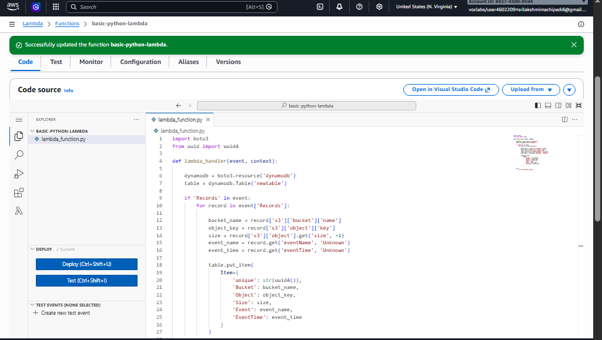
6. Configure Trigger:
- In the Designer section, click on "Add trigger".
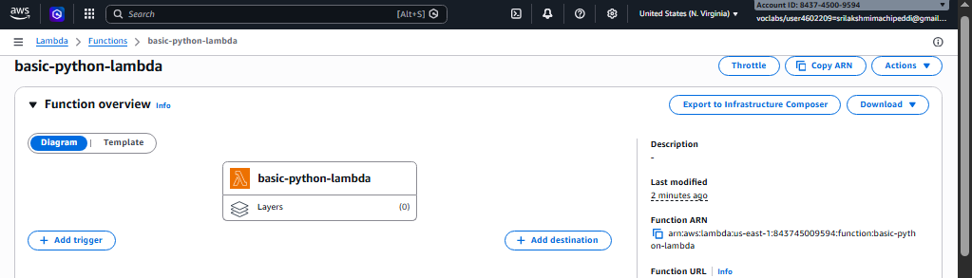
- Select "S3" as the trigger type.
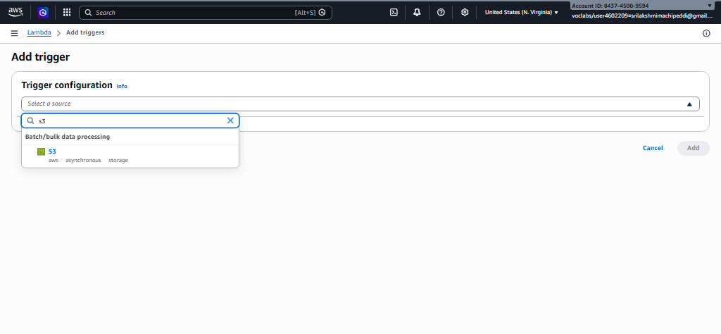
- Configure the trigger to listen to the S3 bucket where you want to trigger the Lambda function.
- Specify the event type (e.g., "All object create events").
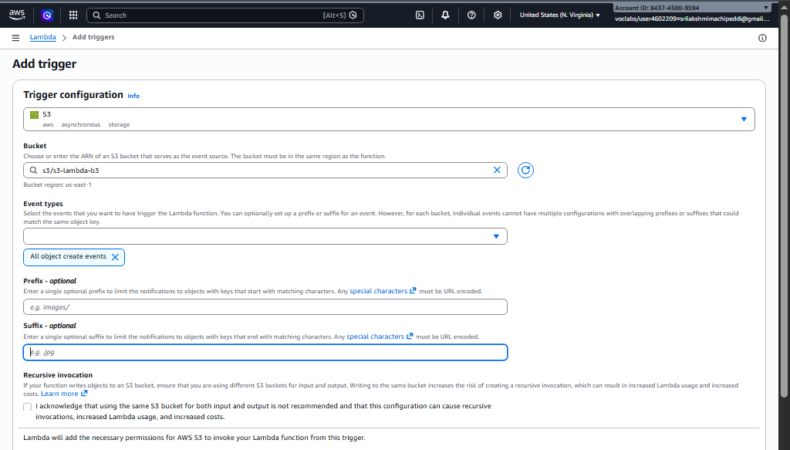
- Click on the "Add" button.

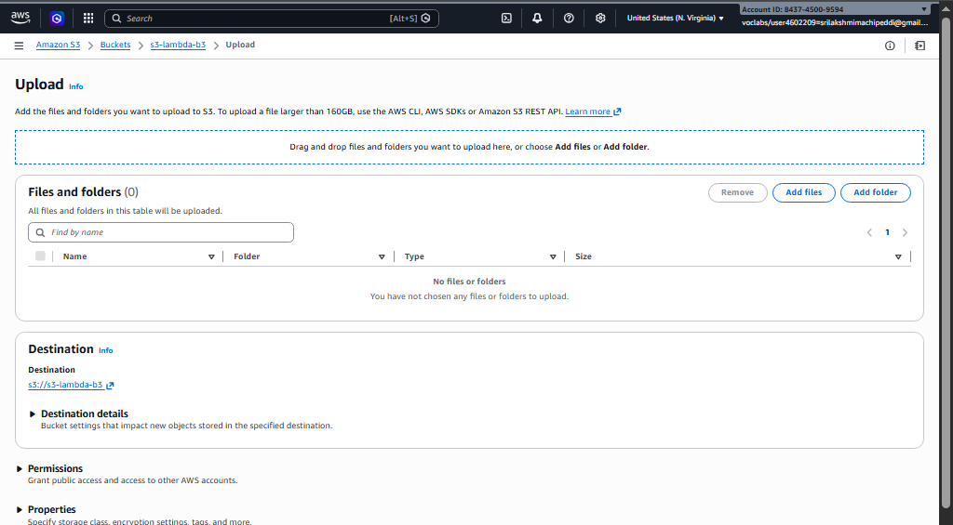

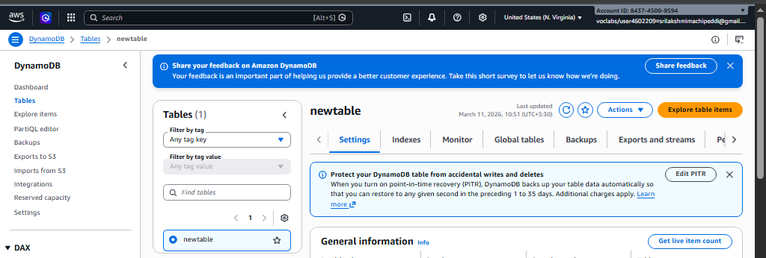

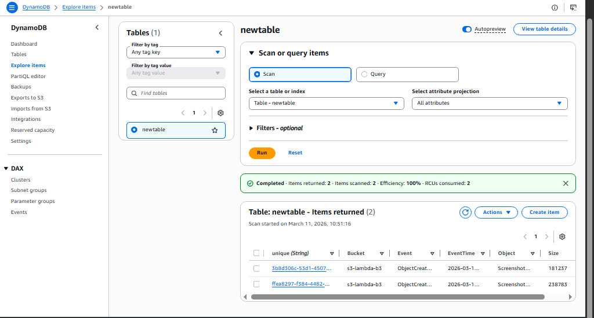
7. Configure Environment Variables (Optional):
- If your Lambda function requires any environment variables (e.g., credentials for accessing DynamoDB), you can set them in the "Configuration" tab under "Environment variables".
8. Test Your Function:
- You can test your Lambda function manually by clicking on the "Test" button in the Lambda console.
- You can create a sample test event or use a custom test event to simulate the S3 event that triggers your function.
9. Save and Deploy:
- Click on the "Deploy" button to deploy your function.
10. Monitor Execution:
- You can monitor the execution of your Lambda function in the Monitoring tab of the Lambda console.
- You can also view logs to troubleshoot any issues that may arise during execution.
successfully set up a Lambda function to trigger whenever an object is uploaded to an S3 bucket and update a DynamoDB table accordingly.
